Postman

🌟 Definition
# Source: AI Source: Provided by: [Data Path: Persons Table -> ID Column: 1, Name_En Column: Motasem Essam] -> From: [ChatGPT] on [6/2/2026]
Postman is an API Development & Collaboration Platform that helps developers design, test, document, mock, monitor, and collaborate on APIs through a graphical user interface (GUI).
Official website:
Postman

🎯 Purpose
# Source: AI Source: Provided by: [Data Path: Persons Table -> ID Column: 1, Name_En Column: Motasem Essam] -> From: [ChatGPT] on [6/2/2026]
Postman allows developers to:
- Send API requests
- Test API responses
- Design APIs
- Document APIs
- Create mock APIs
- Automate API testing
- Collaborate with team members
- Monitor APIs

🔢 Main Features of Postman

1. 📡 Send API Requests
# Source: AI Source: Provided by: [Data Path: Persons Table -> ID Column: 1, Name_En Column: Motasem Essam] -> From: [ChatGPT] on [6/2/2026]
🌟 Purpose
Send HTTP requests to APIs.
Supported methods:
- GET
- POST
- PUT
- PATCH
- DELETE
Example
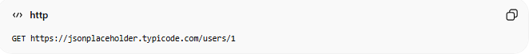
GET https://jsonplaceholder.typicode.com/users/1

2. 👀 View API Responses
# Source: AI Source: Provided by: [Data Path: Persons Table -> ID Column: 1, Name_En Column: Motasem Essam] -> From: [ChatGPT] on [6/2/2026]
🌟 Purpose
Display server responses in a readable format.
Example JSON response:
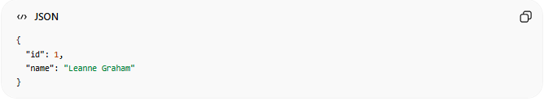
{
"id": 1,
"name": "Leanne Graham"
}

3. 🔐 Authentication & Authorization
# Source: AI Source: Provided by: [Data Path: Persons Table -> ID Column: 1, Name_En Column: Motasem Essam] -> From: [ChatGPT] on [6/2/2026]
🌟 Purpose
Test secured APIs.
Supported authentication:
- Bearer Token
- API Key
- OAuth 2.0
- Basic Auth

4. 🧪 API Testing
# Source: AI Source: Provided by: [Data Path: Persons Table -> ID Column: 1, Name_En Column: Motasem Essam] -> From: [ChatGPT] on [6/2/2026]
🌟 Purpose
Automatically verify API behavior.
Example:
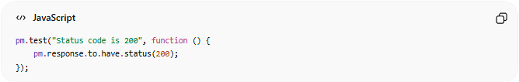
pm.test("Status code is 200", function () {
pm.response.to.have.status(200);
});

5. 📚 API Documentation
# Source: AI Source: Provided by: [Data Path: Persons Table -> ID Column: 1, Name_En Column: Motasem Essam] -> From: [ChatGPT] on [6/2/2026]
🌟 Purpose
Generate and share API documentation.
Documentation can include:
- Endpoints
- Parameters
- Request examples
- Response examples

6. 🎭 Mock APIs
# Source: AI Source: Provided by: [Data Path: Persons Table -> ID Column: 1, Name_En Column: Motasem Essam] -> From: [ChatGPT] on [6/2/2026]
🌟 Purpose
Create fake APIs before the real backend exists.
Example:
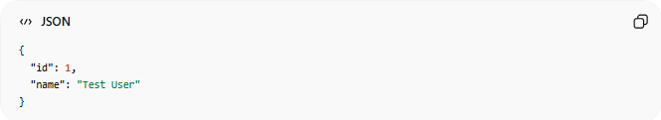
{
"id": 1,
"name": "Test User"
}
Frontend developers can use this fake response while the backend is still being built.

7. 📂 Collections
# Source: AI Source: Provided by: [Data Path: Persons Table -> ID Column: 1, Name_En Column: Motasem Essam] -> From: [ChatGPT] on [6/2/2026]
🌟 Purpose
Group related API requests together.
Example:
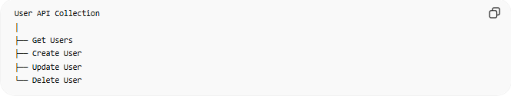
User API Collection
│
├── Get Users
├── Create User
├── Update User
└── Delete User

8. 🌍 Environments
# Source: AI Source: Provided by: [Data Path: Persons Table -> ID Column: 1, Name_En Column: Motasem Essam] -> From: [ChatGPT] on [6/2/2026]
🌟 Purpose
Store variables for different environments.
Examples:
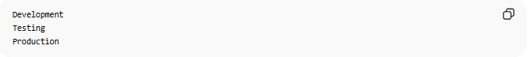
Development
Testing
Production
Variable example:
base_url = https://api.example.com

9. 🤝 Collaboration
# Source: AI Source: Provided by: [Data Path: Persons Table -> ID Column: 1, Name_En Column: Motasem Essam] -> From: [ChatGPT] on [6/2/2026]
🌟 Purpose
Teams can:
- Share collections
- Share documentation
- Review APIs
- Work together

10. 📈 API Monitoring
# Source: AI Source: Provided by: [Data Path: Persons Table -> ID Column: 1, Name_En Column: Motasem Essam] -> From: [ChatGPT] on [6/2/2026]
🌟 Purpose
Automatically check APIs at scheduled intervals.
Examples:
- Check uptime
- Verify response time
- Detect failures

11. 🔄 API Workflows & Automation
# Source: AI Source: Provided by: [Data Path: Persons Table -> ID Column: 1, Name_En Column: Motasem Essam] -> From: [ChatGPT] on [6/2/2026]
🌟 Purpose
Chain requests together.
Example:
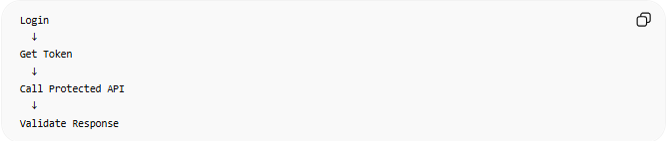
Login
↓
Get Token
↓
Call Protected API
↓
Validate Response

🔗 How Postman Works
# Source: AI Source: Provided by: [Data Path: Persons Table -> ID Column: 1, Name_En Column: Motasem Essam] -> From: [ChatGPT] on [6/2/2026]
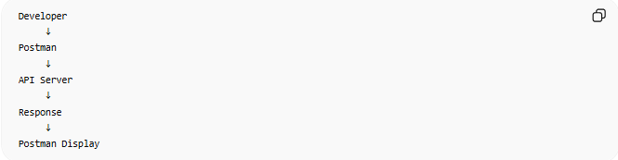
Developer
↓
Postman
↓
API Server
↓
Response
↓
Postman Display

⚖️ Postman vs cURL
# Source: AI Source: Provided by: [Data Path: Persons Table -> ID Column: 1, Name_En Column: Motasem Essam] -> From: [ChatGPT] on [6/2/2026]
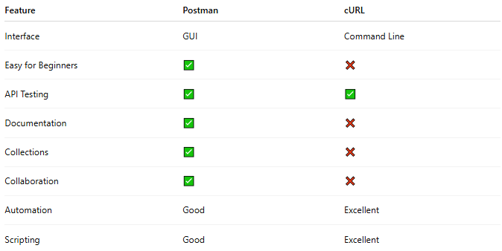
Feature | Postman | cURL
Interface | GUI | Command Line
Easy for Beginners | ✅ | ❌
API Testing | ✅ | ✅
Documentation | ✅ | ❌
Collections | ✅ | ❌
Collaboration | ✅ | ❌
Automation | Good | Excellent
Scripting | Good | Excellent

🧠 Simple Analogy
# Source: AI Source: Provided by: [Data Path: Persons Table -> ID Column: 1, Name_En Column: Motasem Essam] -> From: [ChatGPT] on [6/2/2026]
Think of:
- cURL = typing commands directly to a server 📞
- Postman = a complete control dashboard for working with APIs 🖥️
Both communicate with APIs, but Postman provides many additional tools around that communication.

Download Postman
# Source: ScreenShot Source: Provided by: [Persons Table -> ID Column: 1, Name_En Column: Motasem Essam] -> Tool: [Automation Table -> ID Column: 16, Name_En Column: Screen Capture] -> From [Site: Google Search: All: Postman] on [6/2/2026]
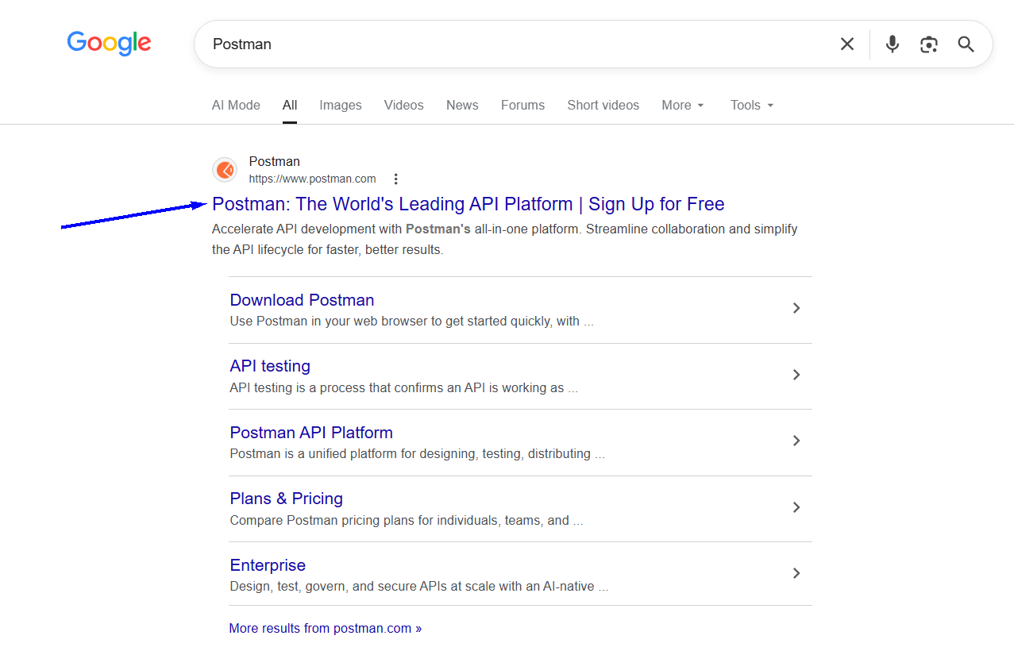
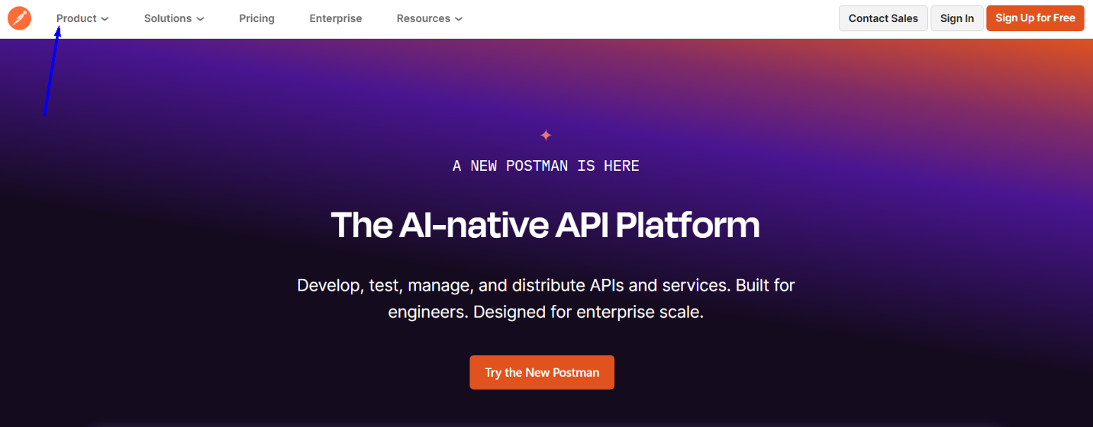
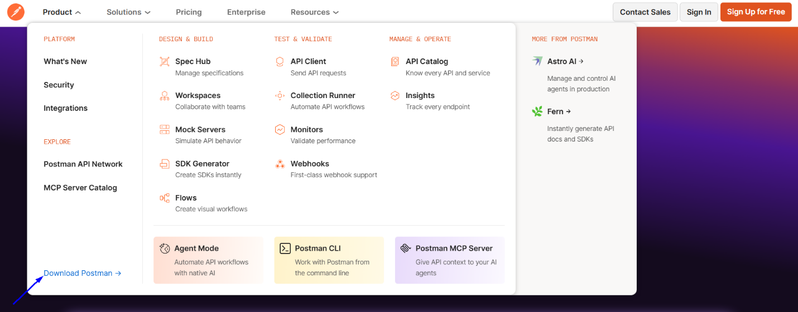
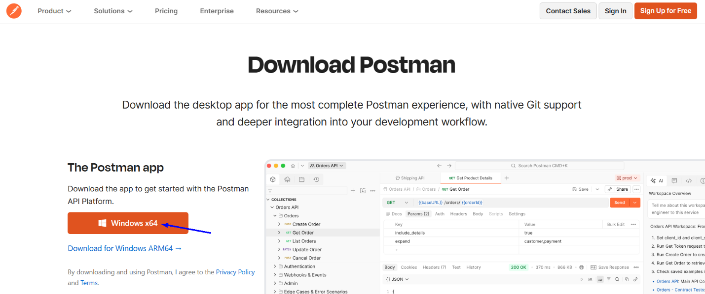

Install Postman
# Source: ScreenShot Source: Provided by: [Persons Table -> ID Column: 1, Name_En Column: Motasem Essam] -> Tool: [Automation Table -> ID Column: 16, Name_En Column: Screen Capture] -> From [Operating System: Windows] on [6/2/2026]
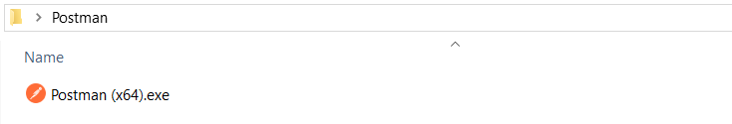
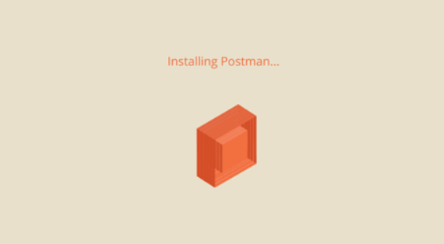

Run Postman
# Source: ScreenShot Source: Provided by: [Persons Table -> ID Column: 1, Name_En Column: Motasem Essam] -> Tool: [Automation Table -> ID Column: 16, Name_En Column: Screen Capture] -> From [Operating System: Windows] on [6/2/2026]
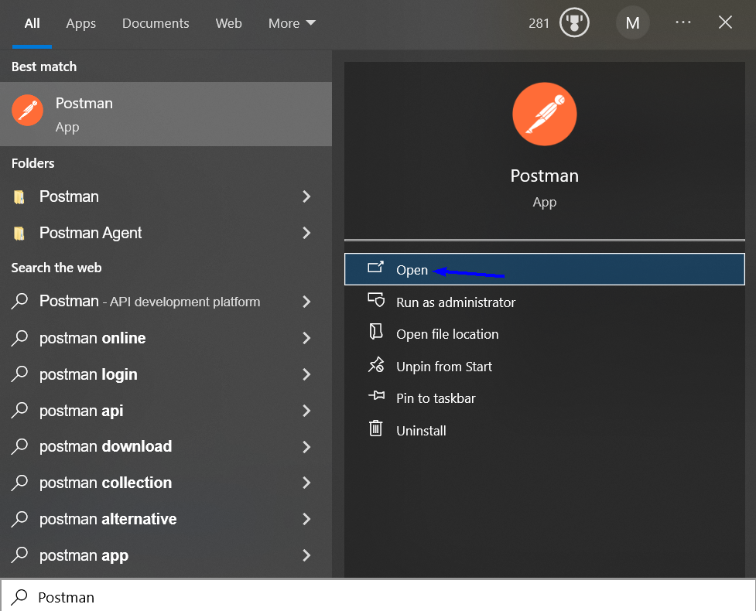
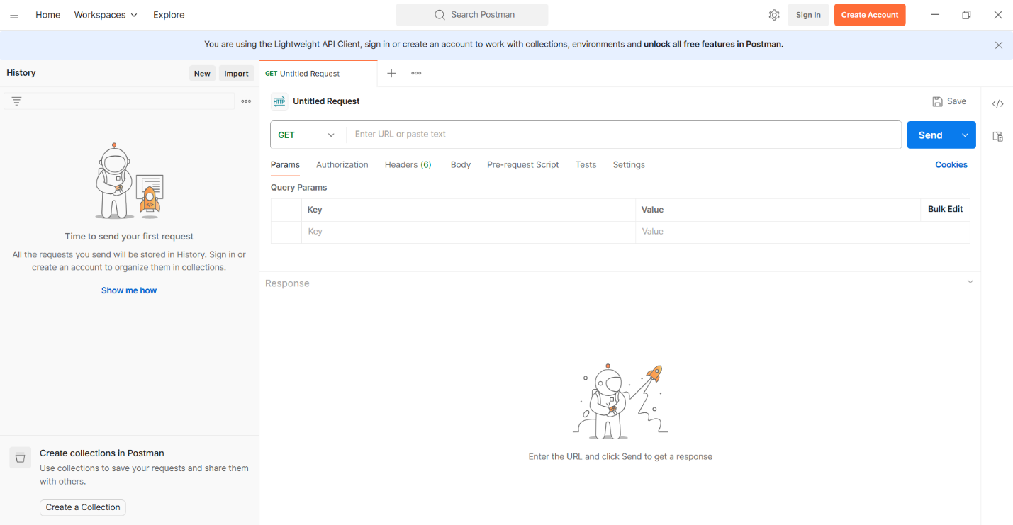

🧭 Summary
# Source: AI Source: Provided by: [Data Path: Persons Table -> ID Column: 1, Name_En Column: Motasem Essam] -> From: [ChatGPT] on [6/2/2026]
Postman is an API Development & Collaboration Platform that allows developers to design, test, document, mock, automate, monitor, and collaborate on APIs through an easy-to-use graphical interface. It is one of the most widely used tools in modern API development.

